**Session report 14/10/2022:**

*LABAUVIE – RAFFAELLI EVA*

*ROB3*

During today’s session I decided to make some researches on the rubbish sorting device.

I started by searching information on the AI camera. But since we haven’t received the Nvidia card yet, and never been taught how to code for image recognition, I decided to switch to another activity.

I decided to go for a first approach in the 3D modelling of the conveyor belt on Fusion 360. After searching for different models of conveyors, I decided to draw my inspiration from the following system:

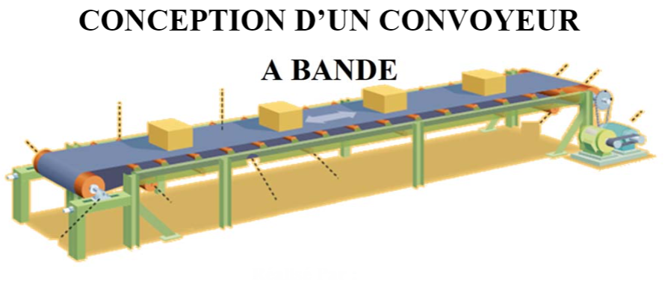

Our Beach Poly’Bot’s conveyor needs to be small enough to fit inside the robot, therefore it probably will measure between 10 to 20 cm. It needs to be precise enough to get stopped at the right time so the camera can scan the object properly.

I found different types of conveyors that can be used for conveying the collected objects:

* 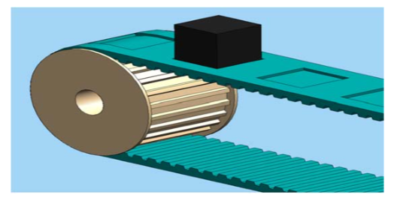We have notched conveyors with notched rollers and belt.
* It also exists conveyors with smooth rollers and belt.

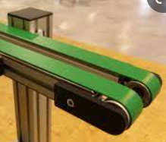

Either ways, every conveyor is composed by:

1. Two rollers at both of the ends
2. Middle rollers (Usually smaller than the previous ones) to help the belt sliding (and a support structure to hold it all together)
3. The transport belt
4. A motor to make the conveyor work

The notched conveyor is said to be more precise, since it stops without having the belt sliding on the rollers. As we need precision to put the rubbish right in front of the camera, I’ll go with this type of conveyor for the moment.

I’m going to model a conveyor that’s around 13 cm long (but this will be possible to change later to adapt with the robot, with the use of parameters).

Here a picture of the outlines of the conveyor:

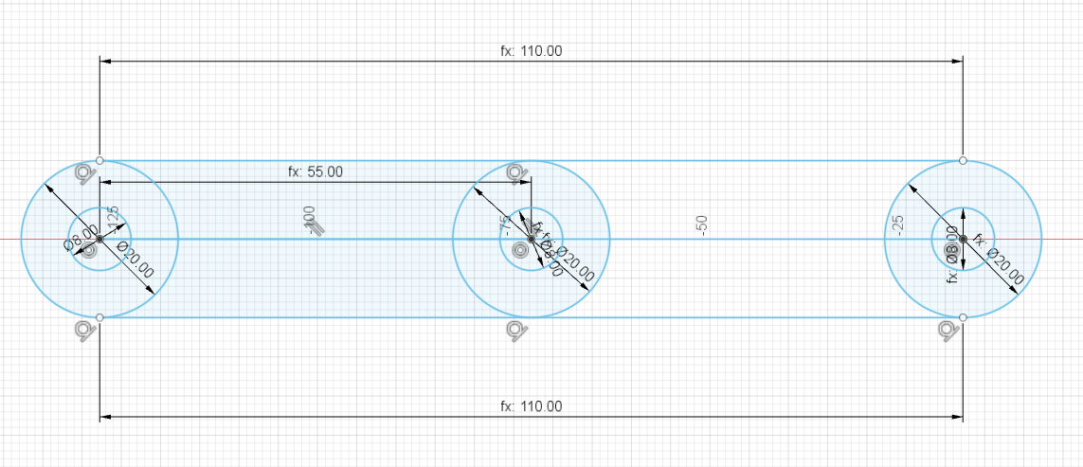

As its goal is to transport objects, the rollers need to be large enough for every picked object to fit. This way I chose to make rollers measure 10 cm long so they can host a 10cm large belt (this can be modified later).

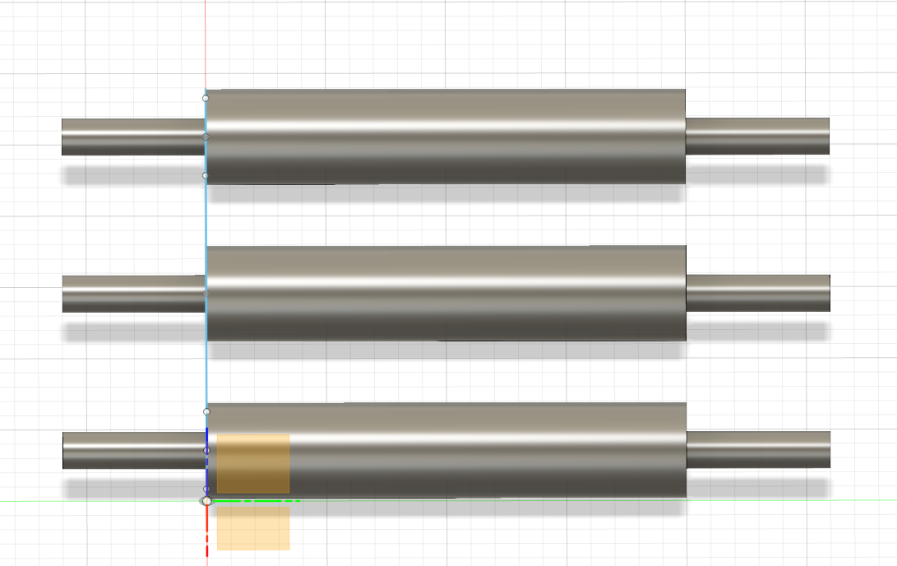

To be able to find the right interval for the notches, I started searching for a notched belt that we could buy.